**Spring Data JPA - Quick Example**

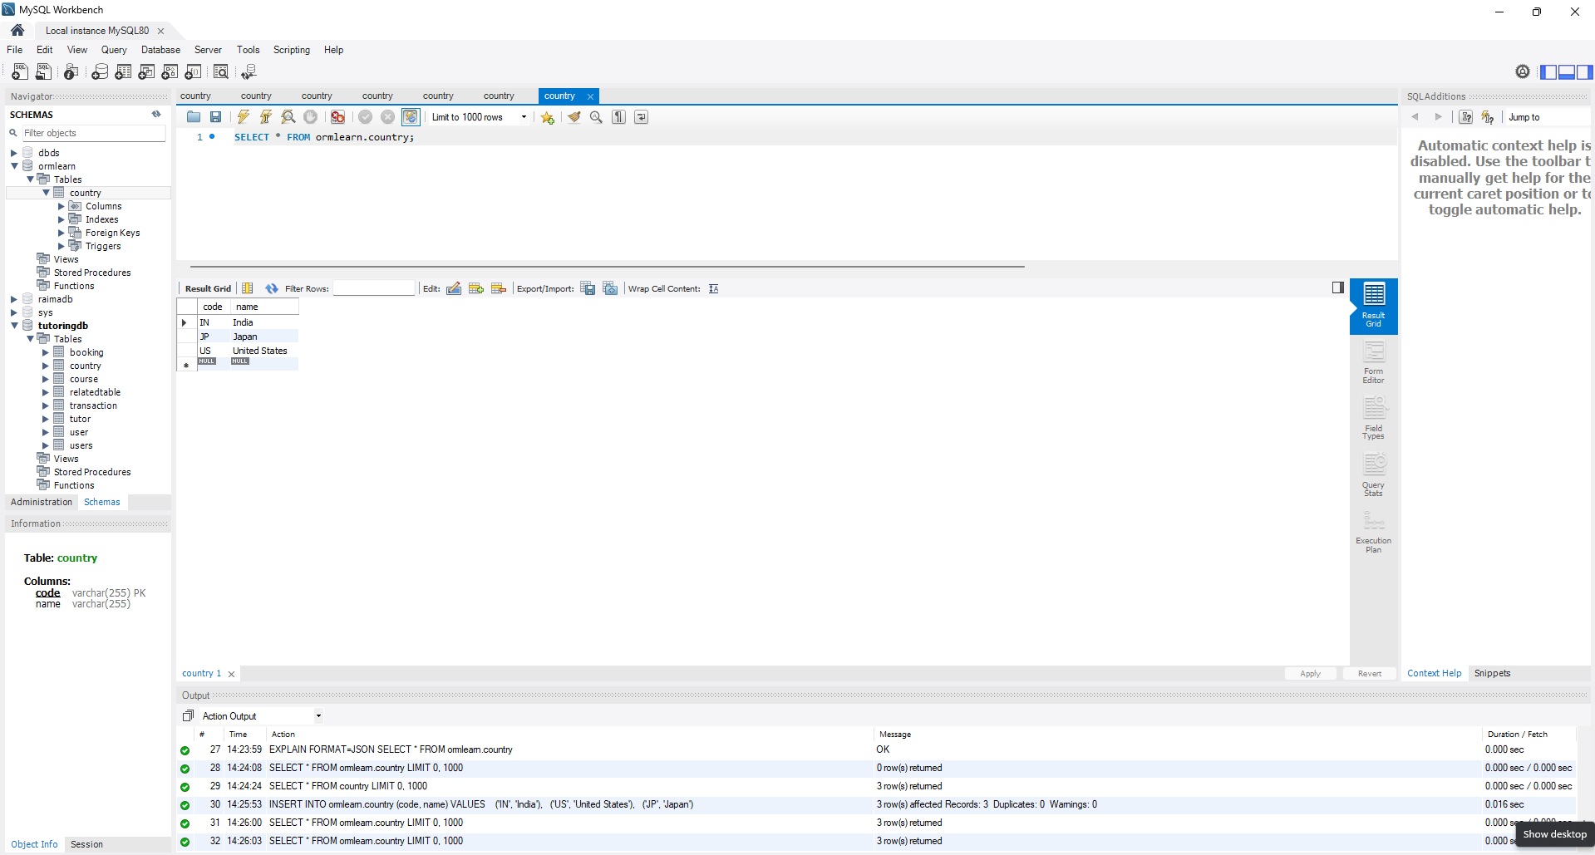

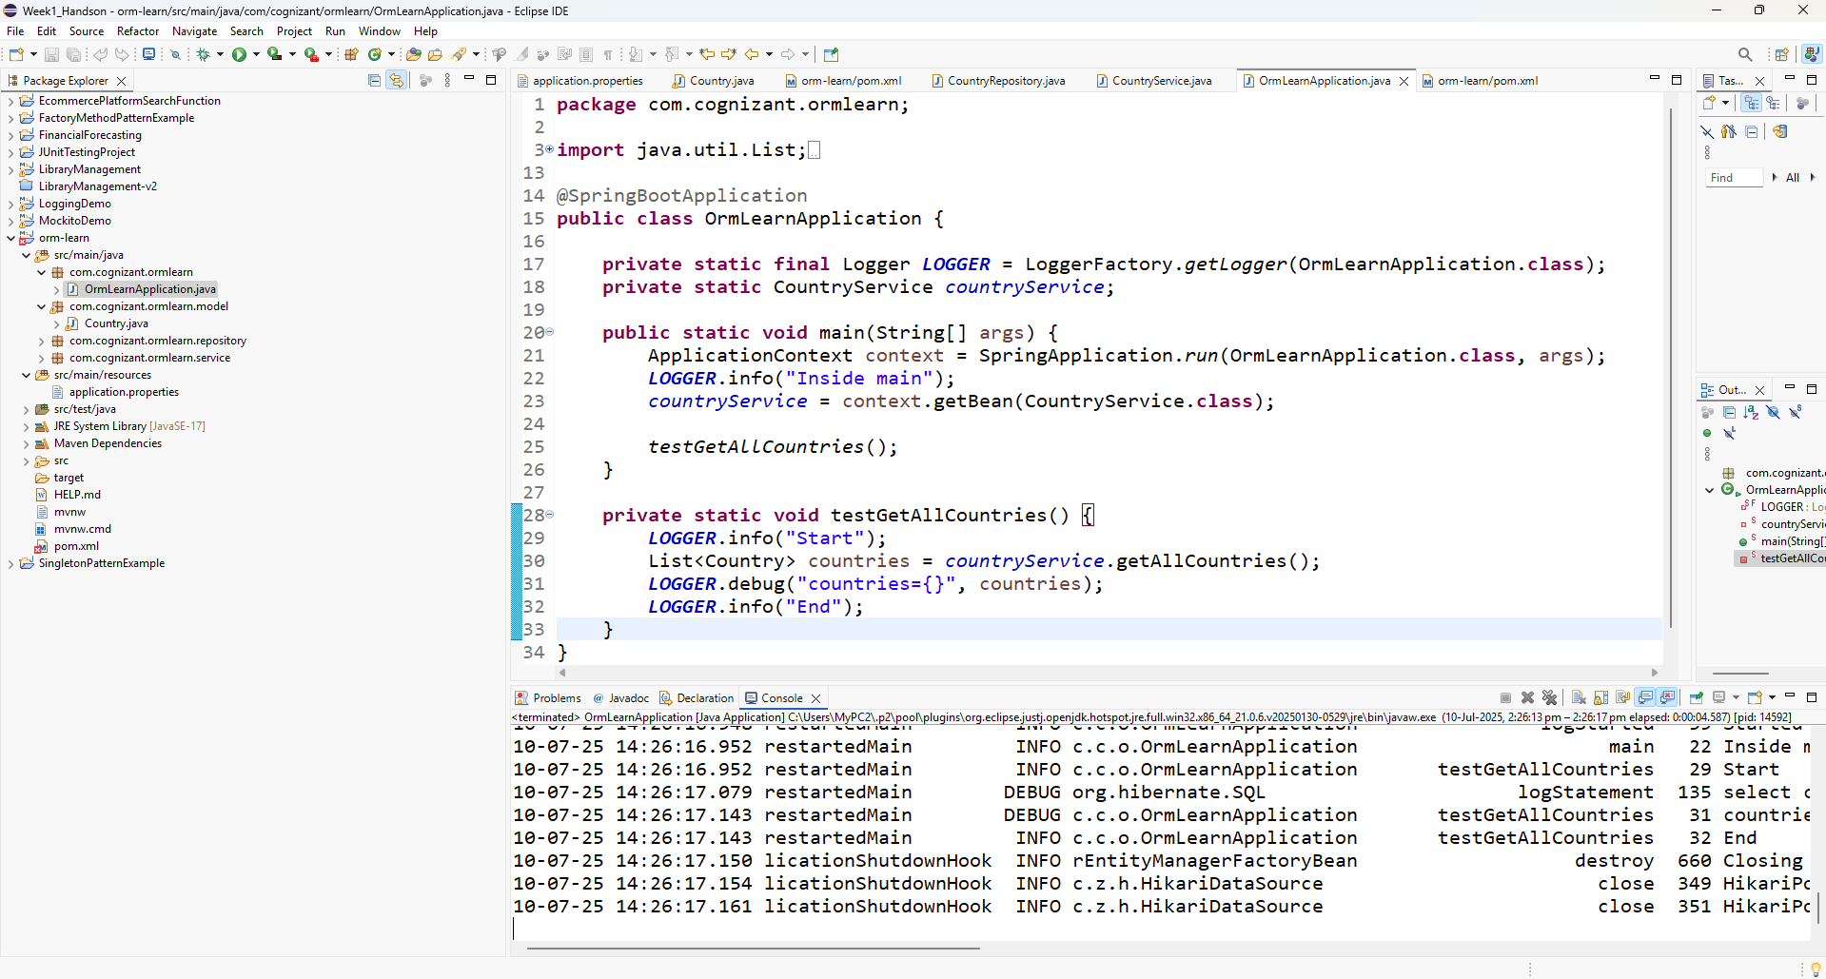

**Difference between JPA, Hibernate and Spring Data JPA**